Dr Davis Collins (1769 – 1840)

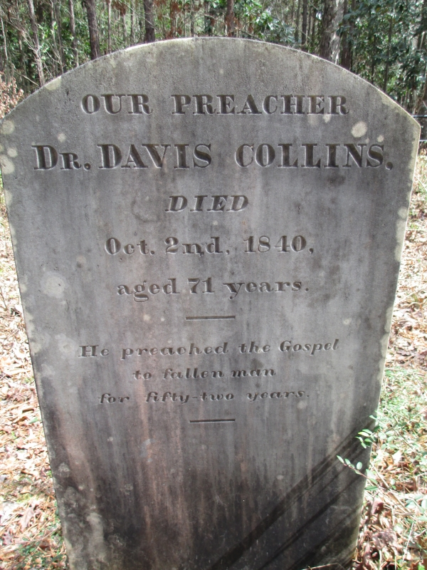
Dr Davis Collins

Birth:
1769
South Carolina, USA
Death:
Oct. 2, 1840
Jackson
East Feliciana Parish
Louisiana, USA

Burial:
Brian Family Cemetery
Jackson
East Feliciana Parish
Louisiana, USA

Added by: William Brown

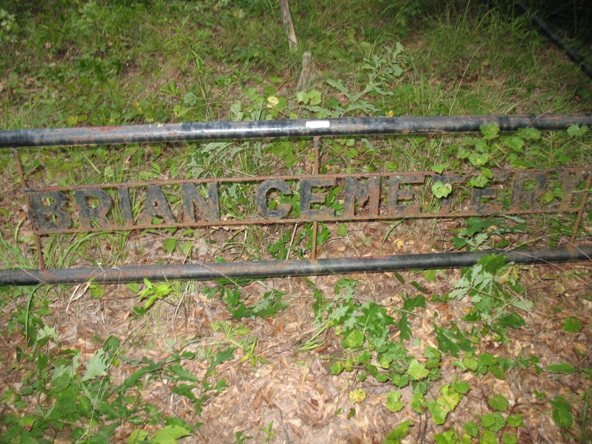
Created by: William Brown
Record added: Mar 05, 2013
Find A Grave Memorial# 106248605

Cemetery Photo
Added by: sworgen58

http://findagrave.com/cgi-bin/fg.cgi?page=gr&GSmpid=48066941&GRid=106248605&

###### # # ##### ####### # # ##### ####### # #
# # ## ## # # # ## # # # # # ## ##
# # # # # # # # # # # # # # # # # #
###### # # # # #### ##### # # # # # # # # #
# # # # # # # # # # # # # # #
# # # # # # # # ## ### # # # # # #
###### # # ##### ####### # # ### ##### ####### # #

Transcribed from original documents by Brent R. Brian & Martha M. Brian.

This document and others can be found on our website:

BMGEN

We claim COPYLEFT on the documents that we publish that are our original work.

COPYLEFT “rules” can be reviewed on the web site:

GNU Free Documentation License

In short, use what you like. But if you use our stuff, mention us as the source.

Brent R. Brian
Martha M. Brian
BrianMitchellGenealogy@gmail.com

